PROGRESS TEST 1
Questions: Application Topic: Student Tuition Payment System
- Students must install and configure all required packages before the test, such as: json-server, react-router-dom, react-bootstrap bootstrap, axios, react-icons,…
- Students must useContext combined with useReducer, axios to get data from json-server, react bootstrap component,…
- Project scaffold: Create a React application named progress-test1
- Project structure:
Organize the source into meaningful folders: components, pages, contexts, services, routes…
Mock data
  - Copy db.json file in the project root to initialize a JSON server.
- Login Form:
Display the login form that authenticates by username or email.
Validation and Behavior:
  - Validate credentials against accounts fetched from db.json.
  - If Username/Email is empty, show “Username or Email is required.” If Password is empty, show “Password is required.”
  - Optionally, check that the password has at least 6 characters or email is not correct format.

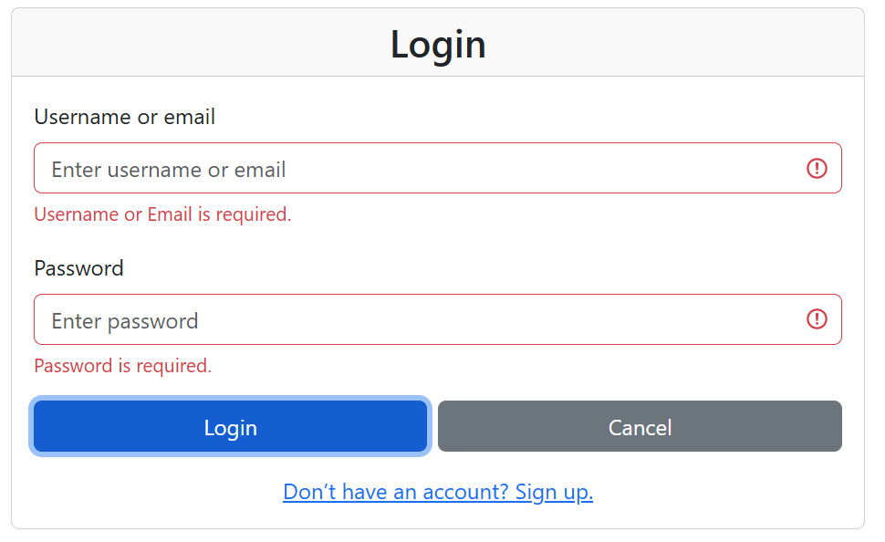
  - If credentials are incorrect, show an alert “Invalid username/email or password!”
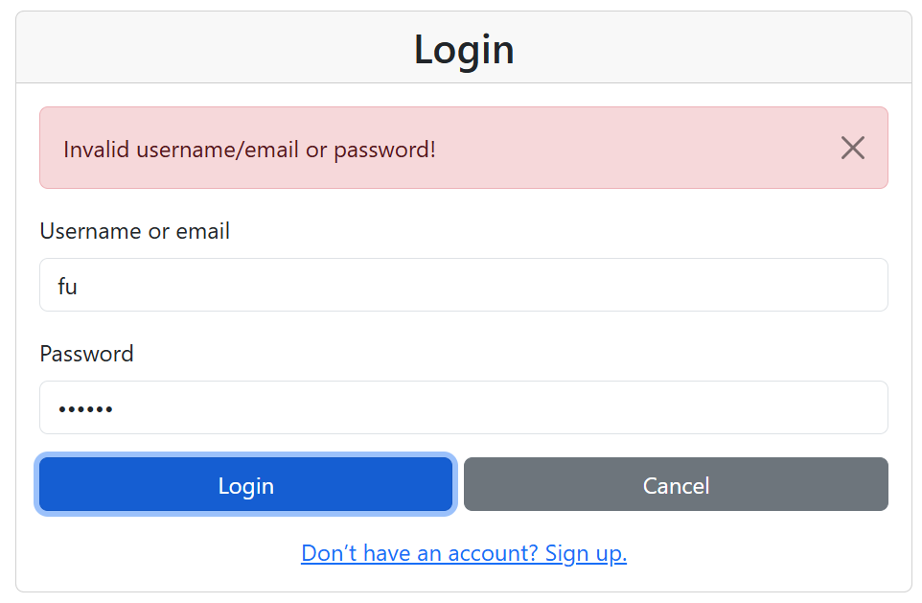
- On success: redirect to /home
Show a modal on the center of the login page, with success message (Welcome, <username>!, login successful.") before redirecting
You should create a ConfirmModal and use it on the login page.

- The dashboard UI (1 mark)
The dashboard page includes these components:
Header (navbar)
- Contain a navigation bar:
  - Left side: Application name TuitionTracker.
  - Right side: Text “Signed in as <FullName>” and a Logout button (redirects to /login and clears token/state).
Card for Filter and Sorting
You should create a FilterBar component and use it on the payment list page.
  - Search by semester or course name
  - Filter by:
    - Semester
    - Course name
  - Sorting:
    - By Course name A->Z
    - By Course name Z->A
    - By Date ascending
    - By Date descending
    - By Amount ascending
    - By Amount descending
---END---

